Mission 9 Assignment Log | Name:
Pre-Mission Preparation
During this mission you will set up an automatic watering system. What automated activities do you use or see?

Mission 9 Checks
Objective #1
Give at least two facts about a relay.

What is the benefit of using a relay?

Objective #2  Explain how to connect the water pump and CodeX to the relay. (You can draw a diagram.) | 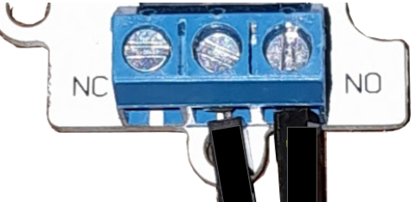
Objective #3
Explain the importance of priming.

What constants are needed for coding the pump?
Objective #4
Explain how conductivity affects the soil moisture sensor?

More water in the soil = __________ = __________

With more water in the soil, the readings will be:
(higher / lower)
Objective #5
What code do you add to the program to include the moisture sensor to control the water pump?

Post-Mission Reflection
Discuss a problem you had with the program. How did you overcome the problem?
Where are some places you may find a relay, or that could use a relay?

